
BSAI-3B
Artificial Intelligence (Lab)
Week-5 (tasks)

(a):
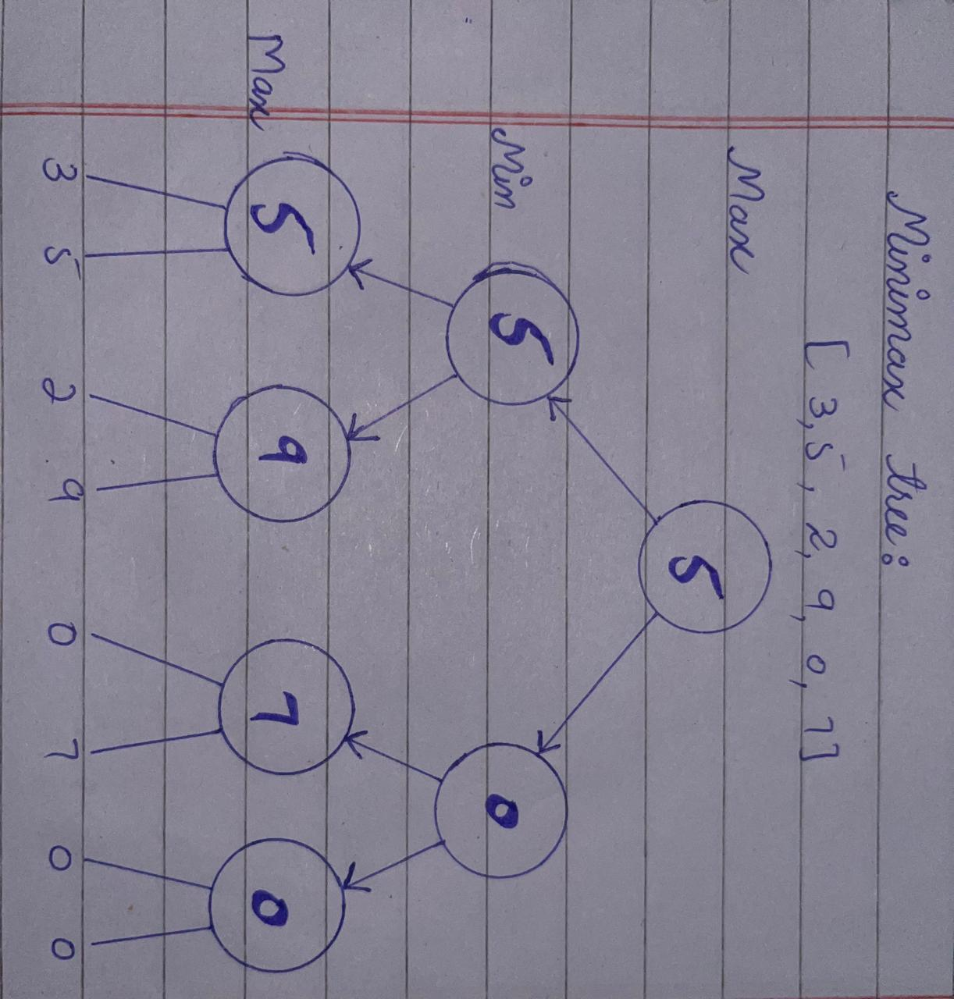
- The last 0 comes from the two additional zeros added to the original scores to complete the binary tree.

(b):
- The scores are initially [3, 5, 2, 9, 0, 7]. Then we add[0,0] at the end to make it a balanced binary tree. These values represents the leaf nodes of tree.
- Use the len(scores) to calculate number of scores which is 8.
- AT the start depth = 0 and node index = 0.
- The program starts and when currentDepth == targetDepth the function reaches a leaf Node. Then leaf score is increased by 1.
- MAX chooses the greater value from each pair.
- MIN chooses the lower value from each pair.
- When it reaches the root node it chooses the greater value which is “5”.
- At the end function adds the leaf count from left to right subtrees.
- As a result all 8 leaf nodes are evaluated.

(c):
- Minimax evaluates all 8 leaf nodes and return 5.
- Alfa-Beta with left first ordering also evaluates all 8 leaves.
- When branch order is reversed, alpha-beta evaluates 6 leaves and prunes the remaining 2.
- The optimal value remains 5 because changing the search order does not change the scores.
- The number of prune nodes depends on order in which branches are explored.

